**Assembling the Animation Machine**

1. Lay the base flat on the work surface and fold all tabs so that they’re pointed up. Fold the sides of the base up so that the tabs are inside the sides of the box and glue them in place with a glue stick. If desired, add the decorative strip to the outside of the base.

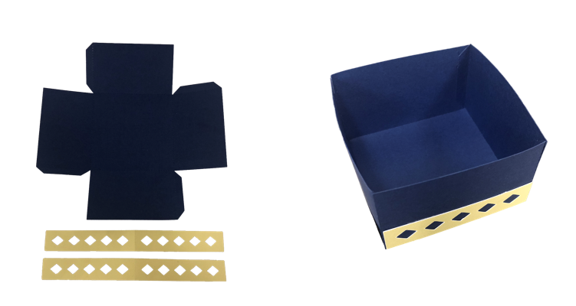

*Mounting Base*

1. Repeat the process with the base lid.

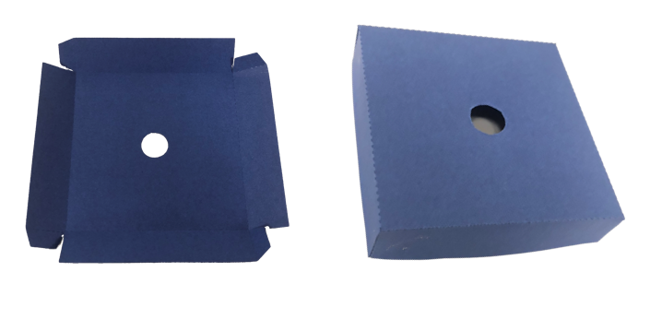

*Mounting Base Lid*

1. Repeat the process with the base insert and place it in the base as shown below.

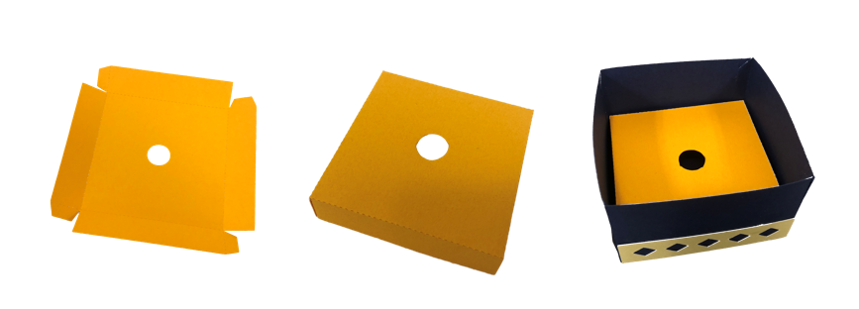

*Mounting Base Insert*

1. Cut a length of plastic straw that is approximately one inch taller than the base. Wrap cardstock around the length of straw until it’s thick enough to fit firmly into the center of the bearing. Wrap cardstock around the spindle below the bearing until it fits firmly in the base.

*Assembled Spindle & Bearing*

1. Insert the spindle through the lid of the base. Then, place the lid on the base and insert the bottom end of the spindle into the mounting base insert.

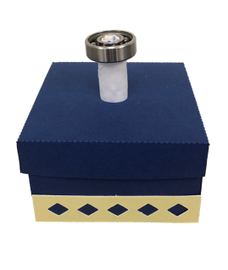

*Spindle and Bearing Inserted into the Mounting Base*

1. Use a glue stick to glue together three disk carrier sheets cut out of cardstock. Press the disk carrier over the bearing so that it is level with the work surface, and glue it in place using superglue. **Note:** Be sure to avoid getting superglue inside the bearing.

*Disk Carrier Mounted onto the Bearing Hub*

1. Place the animation disk on top of the carrier disk. Do **not** glue the animation disk in place.

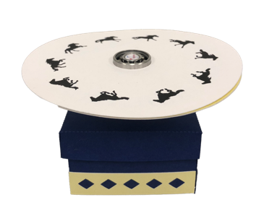

*Animation Disk Placed on Disk Carrier*

1. Use the Reflective Cone vector file to cut a cone out of mirrored cardstock. Fold the cone as shown below and use a glue stuck to connect the edges.  
     
     
    A close-up of a book

   Description automatically generated with low confidence

*Reflective Cone*

1. Press the reflective cone over the bearing to complete the animation machine.

*The Assembled Animation Machine*